**Convolutional Neural Network**

Study Notes by Jane Huang (Credit to Andrew NG)

08172018

Contents

Week 1 Foundations of Convolutional Neural Networks 2

1.1 Computer vision 2

1.2 Edge detection 2

1.3 Padding 5

1.4 Strided convolutions 6

1.5 Convolutions over volumes 7

1.6 A simple convolution network example 9

1.7 Pooling layers 11

1.8 Convolutional neural network example 12

1.9 Why convolutions 13

1.10 Quiz 14

Week 2 Deep convolutional models: case studies 16

2.1 Why Look At Case Studies 16

2.2 Classic Networks 16

2.3 ResNets 18

2.4 Network in Network and 1x1 19

2.5 Inception Network Motivation 20

2.6 Inception Network 21

2.7 MobileNet 22

2.8 EfficientNet 23

2.9 Common augmentation method 24

Week 3 Object detection 24

3.1-ObjectLocalization 24

3.2-LandmarkDetection 25

3.3-ObjectDetection 26

3.4-ConvImpSlidingWindows 27

3.6InstersecOverUnion 28

3.7-NonmaxSuppression 29

3.8-AnchorBoxes 31

3.9-YOLOAlgorithm 32

3.10-RegionProposals 33

3.11 Semantic segmentation with U-Net 34

Week 4 Special applications: Face recognition & Neural style transfer 35

4.1-What Is Face Recog 35

4.2-One Shot Learning 35

4.3-Siamese Network 36

4.4-Triplet Loss 37

4.5-Face verification and binary classification 39

4.6-What Is Neural Transfer Style 40

4.7-What Are Deep CNs Learning 40

4.8-Cost Function 44

4.9-Content Cost Function 45

4.10-Style Cost Function 45

4.11 1D and 3D generalizations of models 47

**Week 1 Foundations of Convolutional Neural Networks**

**1.1 Computer vision**

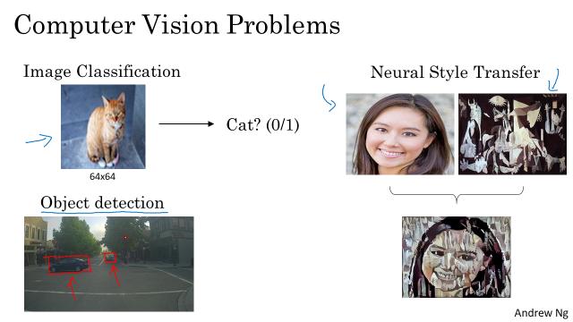

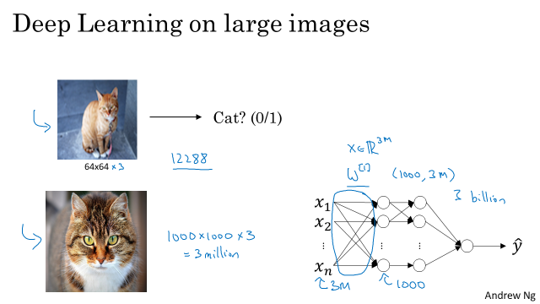

**1.2 Edge detection**

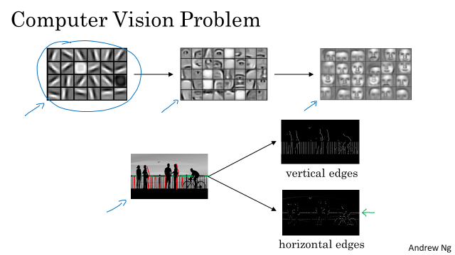

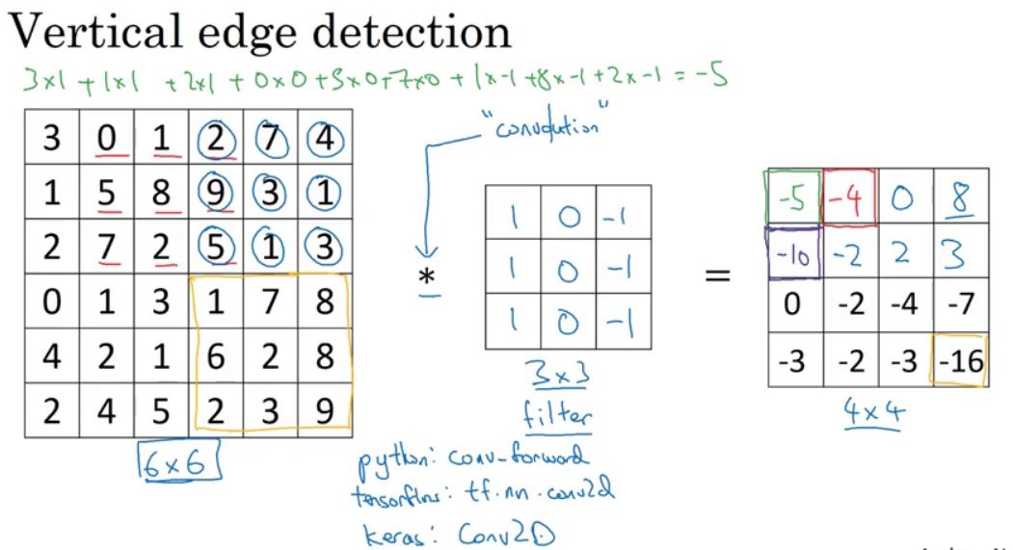

Convolution: elementwise product

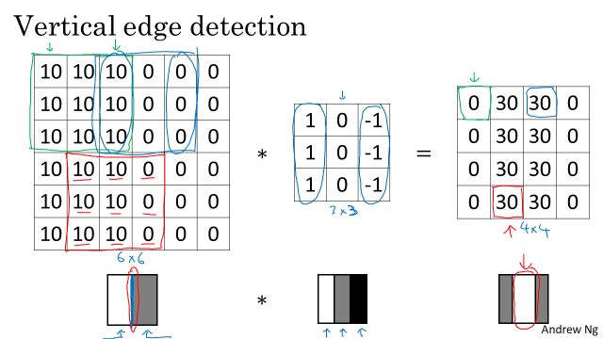

Maybe one intuition to take away from vertical edge detection is that a vertical edge is a three by three region since we are using a 3 by 3 filter where there are bright pixels on the left, you do not care that much what is in the middle and dark pixels on the right. The middle in this 6 by 6 image is really where there could be bright pixels on the left and darker pixels on the right and that is why it thinks its a vertical edge over there. The convolution operation gives you a convenient way to specify how to find these vertical edges in an image. 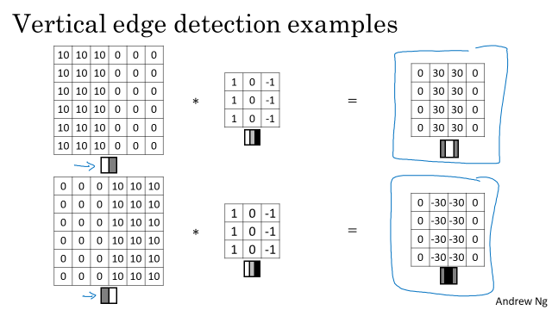

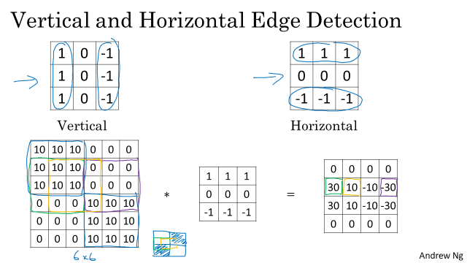

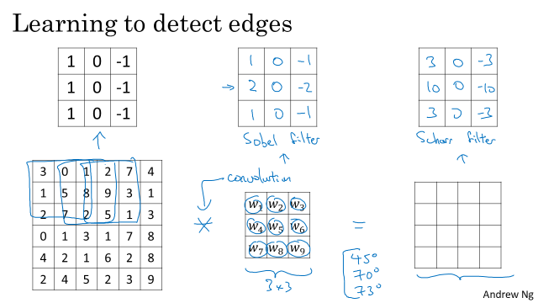

This is called a Sobel filter. And the advantage of this is it puts a little bit more weight to the central row, the central pixel, and this makes it maybe a little bit more robust. But computer vision researchers will use other sets of numbers as well, like maybe instead of a 1, 2, 1, it should be a 3, 10, 3, right? And then -3, -10, -3. And this is called a Scharr filter.

So by just letting all of these numbers be parameters and learning them automatically from data, we find that neural networks can actually learn low level features, can learn features such as edges, even more robustly than computer vision researchers are generally able to code up these things by hand. But underlying all these computations is still this convolution operation, Which allows back propagation to learn whatever three by three filter it wants and then to apply it throughout the entire image, at this position, at this position, at this position, in order to output whatever feature it's trying to detect. Be it vertical edges, horizontal edges, or edges at some other angle or even some other filter that we might not even have a name for in English.

**1.3 Padding**

So in order to fix both of these problems, what you can do is the full apply of convolutional operation. You can pad the image. So in this case, let's say you pad the image with an additional one border, with the additional border of one pixel all around the edges.

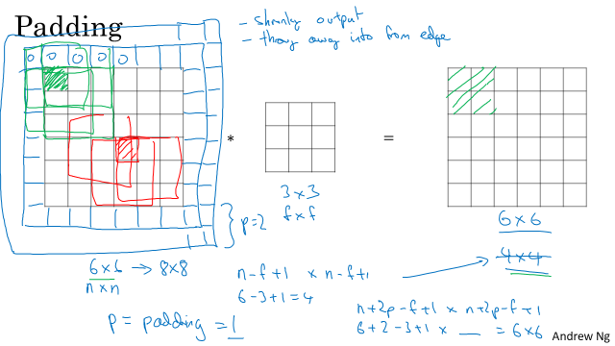

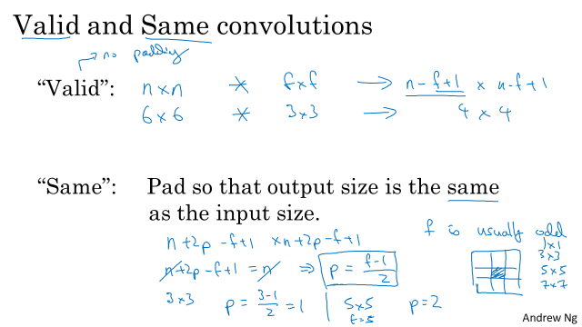

**1.4 Strided convolutions**

Strided convolutions is another piece of the basic building block of convolutions as used in Convolutional Neural Networks.

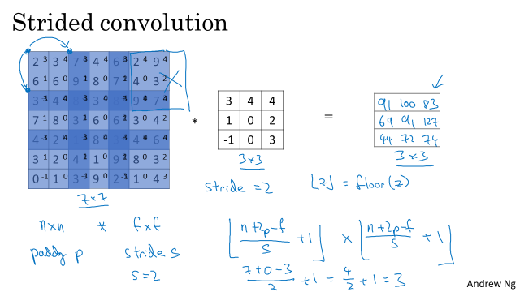

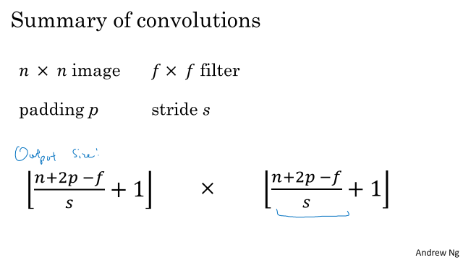

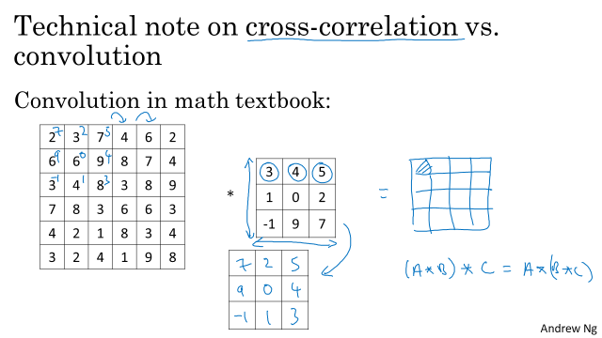

**1.5 Convolutions over volumes**

Let's just summarize the dimensions, if you have a n by n by number of channels input image, so an example, there's a six by six by three, where n subscript C is the number of channels, and you convolve that with a f by f by, and again, this should be the same nC, so this was, three by three by three, and by convention this and this have to be the same number. Then, what you get is n minus f plus one by n minus f plus one by and you want to use this nC prime, or its really nC of the next layer, but this is the number of filters that you use. So this in our example would be be four by four by two. And I wrote this assuming that you use a stride of one and no padding. But if you used a different stride of padding than this n minus F plus one would be affected in a usual way, as we see in the previous videos. So this idea of convolution on volumes, turns out to be really powerful. Only a small part of it is that you can now operate directly on RGB images with three channels. But even more important is that you can now detect two features, like vertical, horizontal edges, or 10, or maybe a 128, or maybe several hundreds of different features. And the output will then have a number of channels equal to the number of filters you are detecting.

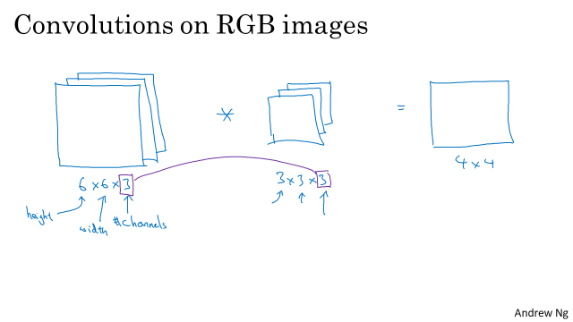

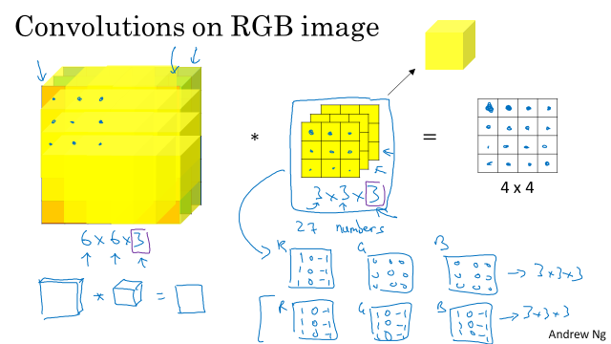

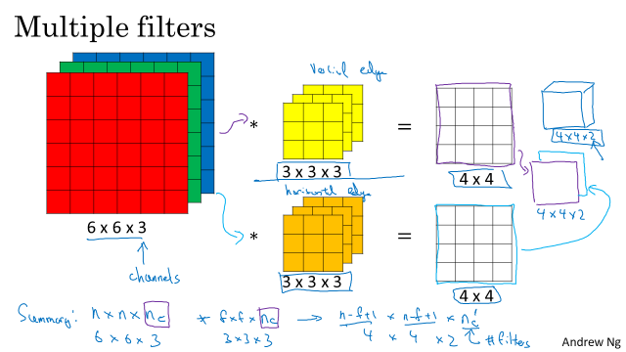

1.6 A simple convolution network example

One layer of a convolutional network: if we have n filters, then the output will be 4 by 4 by n

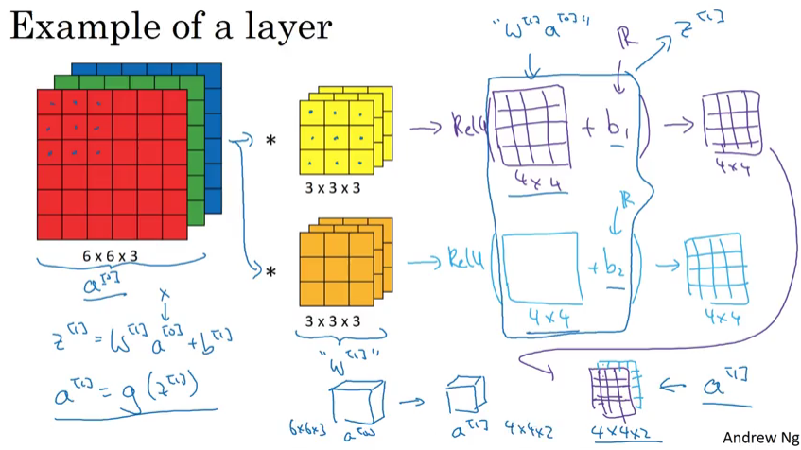

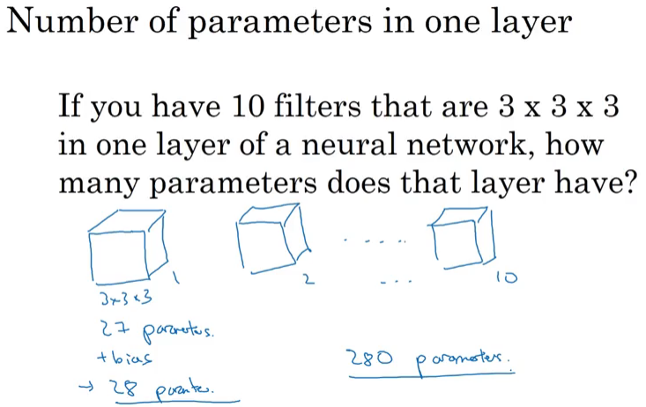

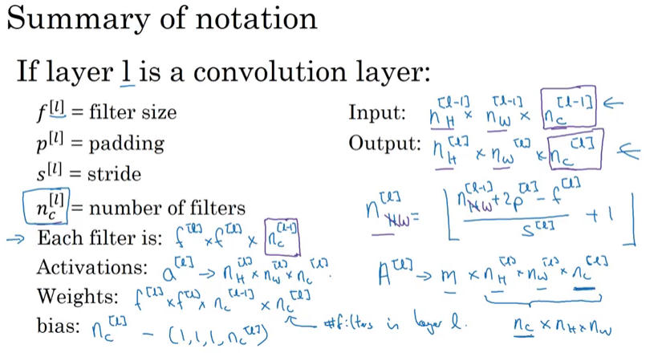

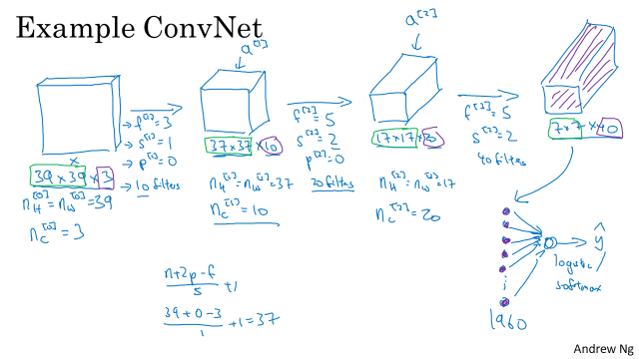

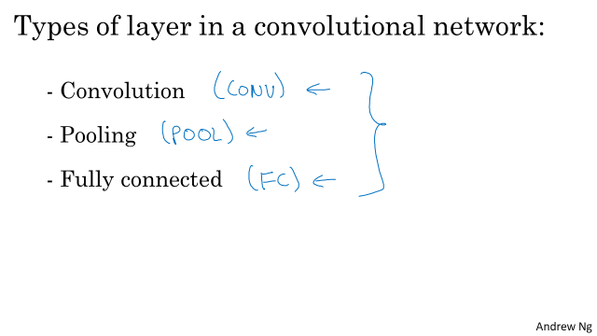

**1.7 Pooling layers**

ConvNets often also use pooling layers to reduce the size of the representation, to speed the computation, as well as make some of the features that detects a bit more robust.

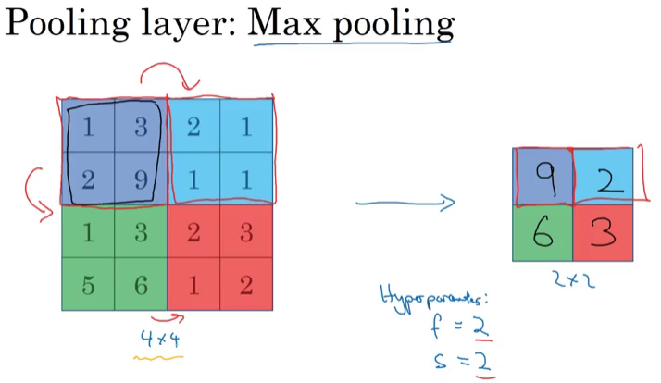

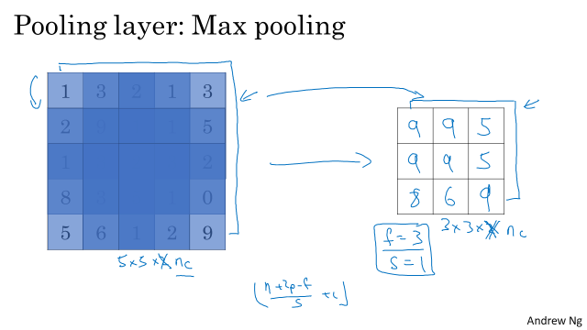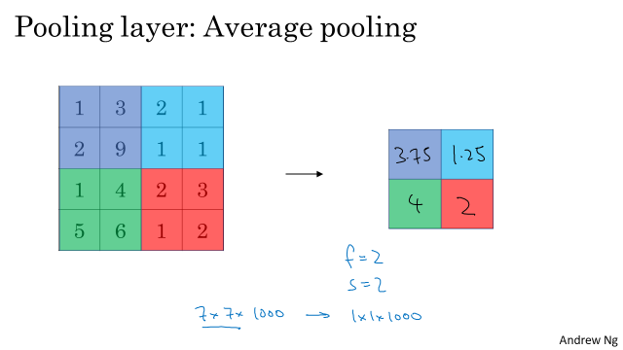

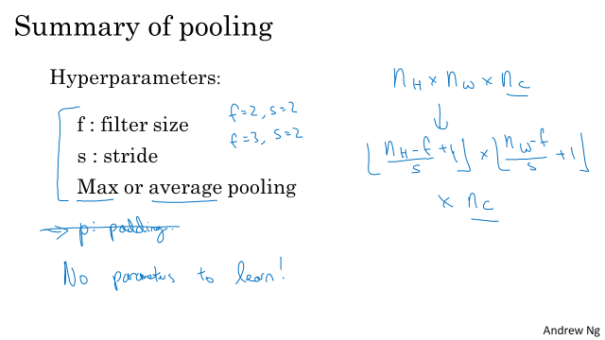

Normally, max pooling doesn’t use padding

**1.8 Convolutional neural network example**

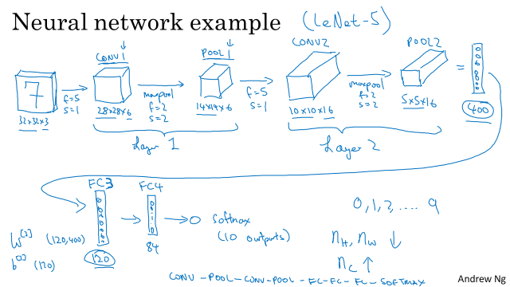

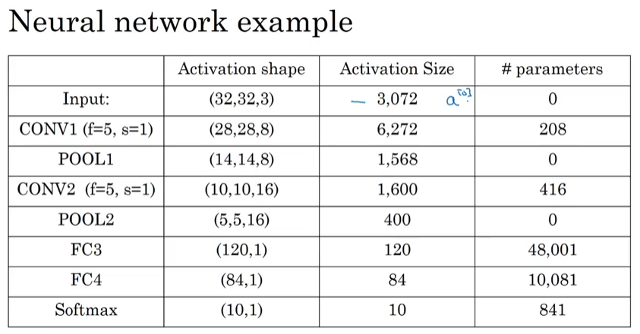

**1.9 Why convolutions**

I think there are two main advantages of convolutional layers over just using fully connected layers. And the advantages are parameter sharing and sparsity of connections.

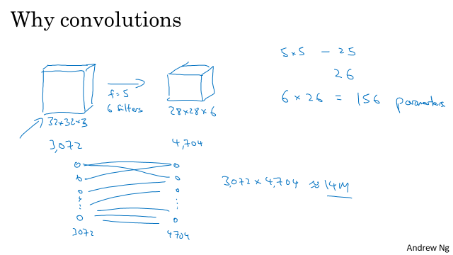

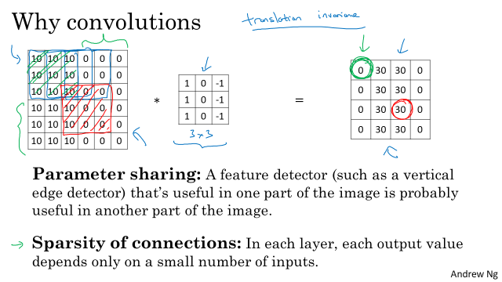

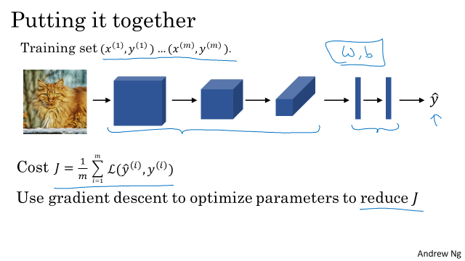

**1.10 Quiz**

**Question 1**

What do you think applying this filter to a grayscale image will do?

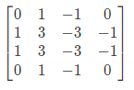​

Answer: Detect vertical edges

As you can see the difference between values from the left part and values from the right of this filter is high. When convolving this filter on a grayscale image, the vertical edges will be detected.

**Question 2**

Suppose your input is a 300 by 300 color (RGB) image, and you are not using a convolutional network. If the first hidden layer has 100 neurons, each one fully connected to the input, how many parameters does this hidden layer have (including the bias parameters)?

Answer: 27000100

The number of weights is 300×300×3×100=27,000,000, when you add the bias terms (one per neurons) you get 27,000,100

**Question 3**

Suppose your input is a 300 by 300 color (RGB) image, and you use a convolutional layer with 100 filters that are each 5x5. How many parameters does this hidden layer have (including the bias parameters)?

Answer:7600

Correct, you have 25 \times 3 = 7525×3=75 weights and 11 bias per filter. Given that you have 100 filters, you get 7,600 parameters for this layer.

**Question 4**

You have an input volume that is 63x63x16, and convolve it with 32 filters that are each 7x7, using a stride of 2 and no padding. What is the output volume?

Answer:29*29*32

Where n_c=32, 29= (63-7)/2+1 

**Question 5**

You have an input volume that is 15x15x8, and pad it using “pad=2.” What is the dimension of the resulting volume (after padding)?

Answer:19*19*8 where 19=15+2*2

Correct, padding is applied over the height and the width of the input image. If the padding is two, you add 4 to the height dimension and 4 the width dimension.

**Question 6**

You have an input volume that is 63x63x16, and convolve it with 32 filters that are each 7x7, and stride of 1. You want to use a “same” convolution. What is the padding?

Answer:3

Correct, you need to satisfy the following equation: 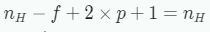

as you want to keep the dimensions between the input volume and the output volume

**Question 7**

You have an input volume that is 32x32x16, and apply max pooling with a stride of 2 and a filter size of 2. What is the output volume?

Answer:16*16*16

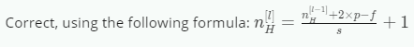

**Question 8**

Because pooling layers do not have parameters, they do not affect the backpropagation (derivatives) calculation.

Answer:False

Everything that influences the loss should appear in the backpropagation because we are computing derivatives. In fact, pooling layers modify the input by choosing one value out of several values in their input volume. Also, to compute derivatives for the layers that have parameters (Convolutions, Fully-Connected), we still need to backpropagate the gradient through the Pooling layers.

**Question 9**

In lecture we talked about “parameter sharing” as a benefit of using convolutional networks. Which of the following statements about parameter sharing in ConvNets are true? (Check all that apply.)

Answer:

* It reduces the total number of parameters, thus reducing overfitting. (correct)
* It allows parameters learned for one task to be shared even for a different task (transfer learning). (wrong)
* It allows gradient descent to set many of the parameters to zero, thus making the connections sparse. (wrong)
* It allows a feature detector to be used in multiple locations throughout the whole input image/input volume. (correct)

**Question 10**

In lecture we talked about “sparsity of connections” as a benefit of using convolutional layers. What does this mean?

Answer: Each activation in the next layer depends on only a small number of activations from the previous layer.

Yes, each activation of the output volume is computed by multiplying the parameters from **only one filter** with a volumic slice of the input volume and then summing all these together.

**Week 2 Deep convolutional models: case studies**

**2.1 Why Look At Case Studies**

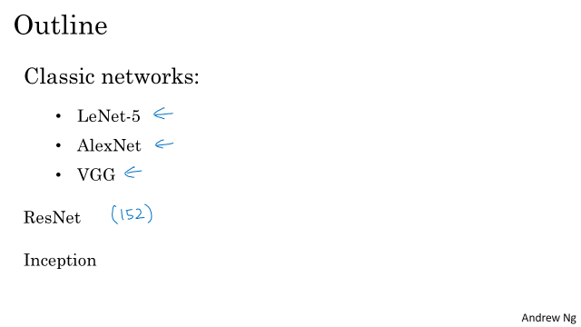

**2.2 Classic Networks**

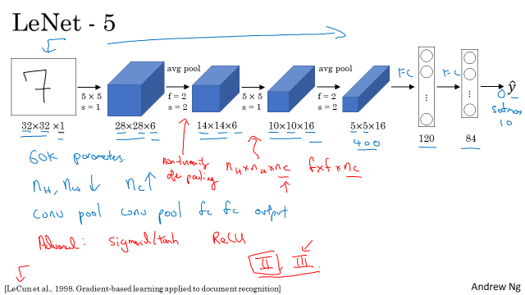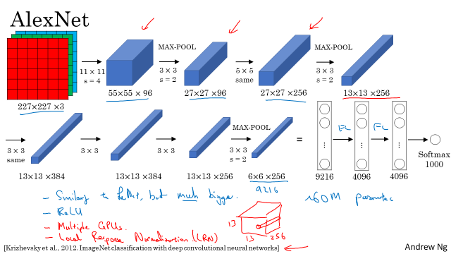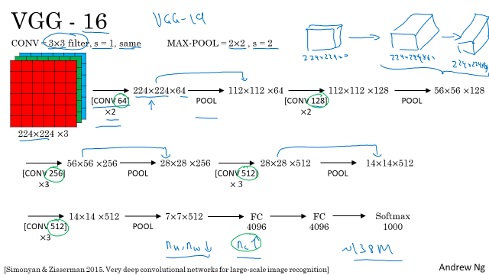

**2.3 ResNets**

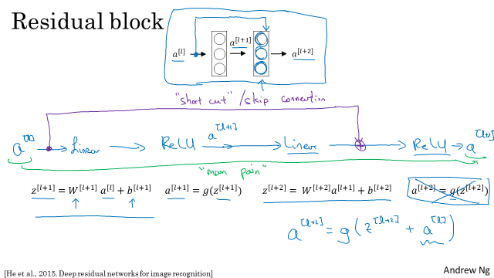

* The skip-connection makes it easy for the network to learn an identity mapping between the input and the output within the ResNet block
* Using a skip-connection helps the gradient to backpropagate and thus helps you to train deeper networks

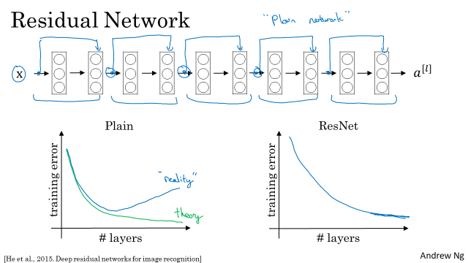

**2.4 Network in Network and 1x1**

Suppose you have an input volume of dimension *nH*​ x *nW*​ x *nC*





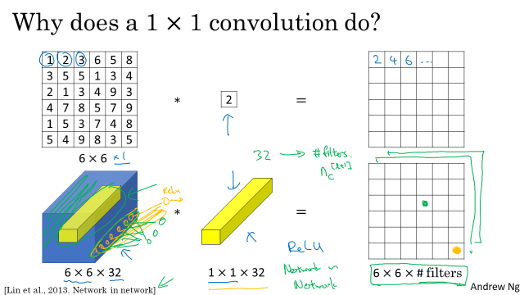

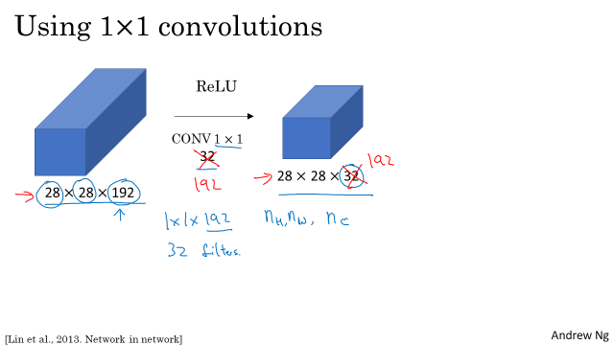

2.5 Inception Network Motivation

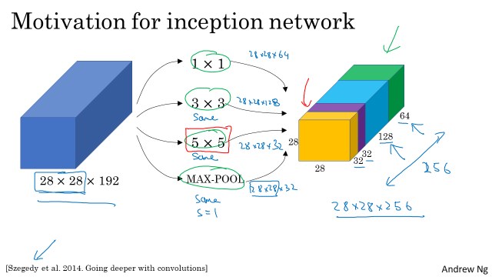

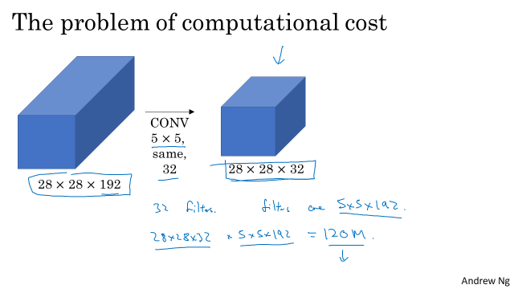

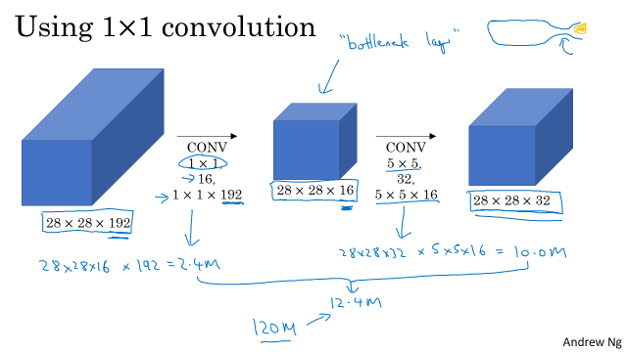

**2.6 Inception Network**

* A single inception block allows the network to use a combination of 1x1, 3x3, 5x5 convolutions and pooling.
* Inception blocks usually use 1x1 convolutions to reduce the input data volume’s size before applying 3x3 and 5x5 convolutions.

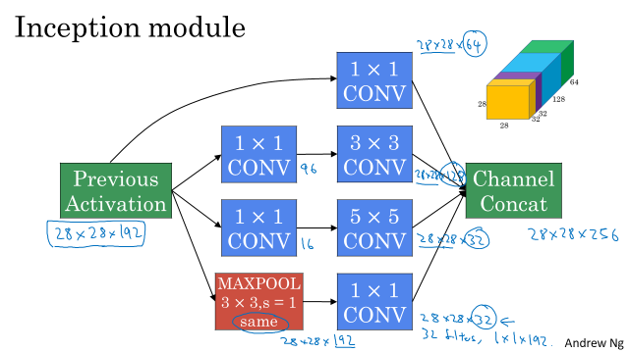

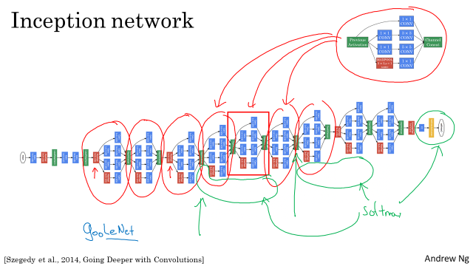

**2.7 MobileNet**

Motivation for MobileNets

• Low computational cost at deployment

• Useful for mobile and embedded vision applications

• Key idea: Normal vs. depthwise-separable convolutions

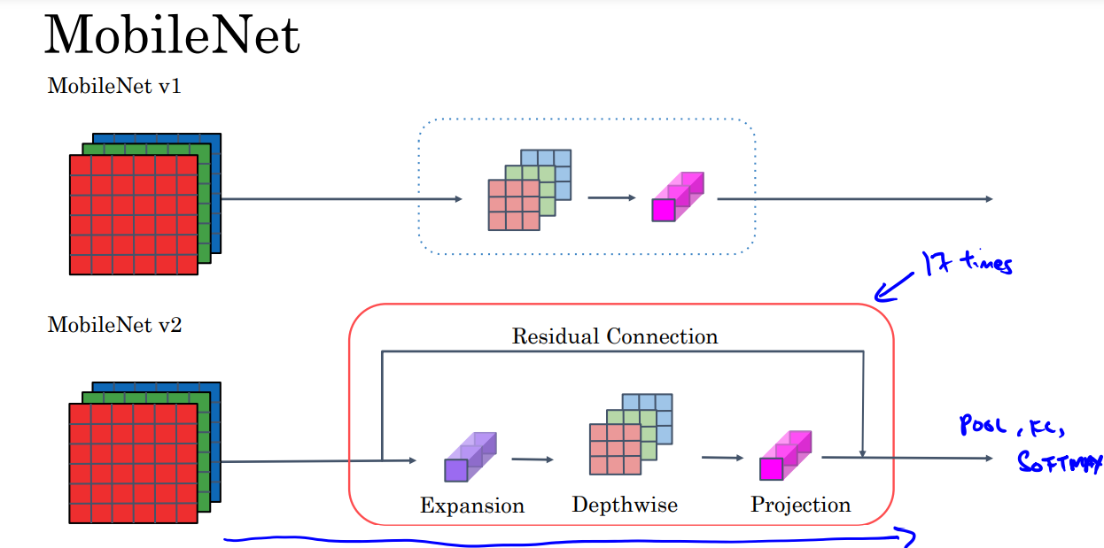

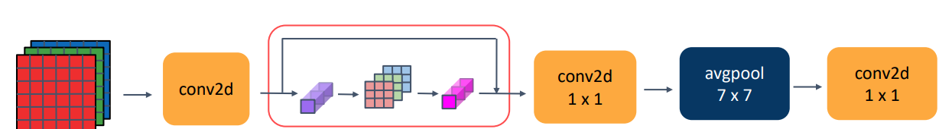

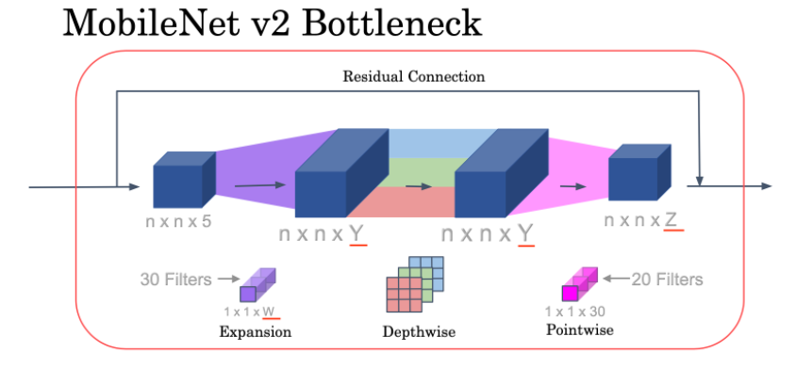

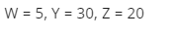

**2.8 EfficientNet**

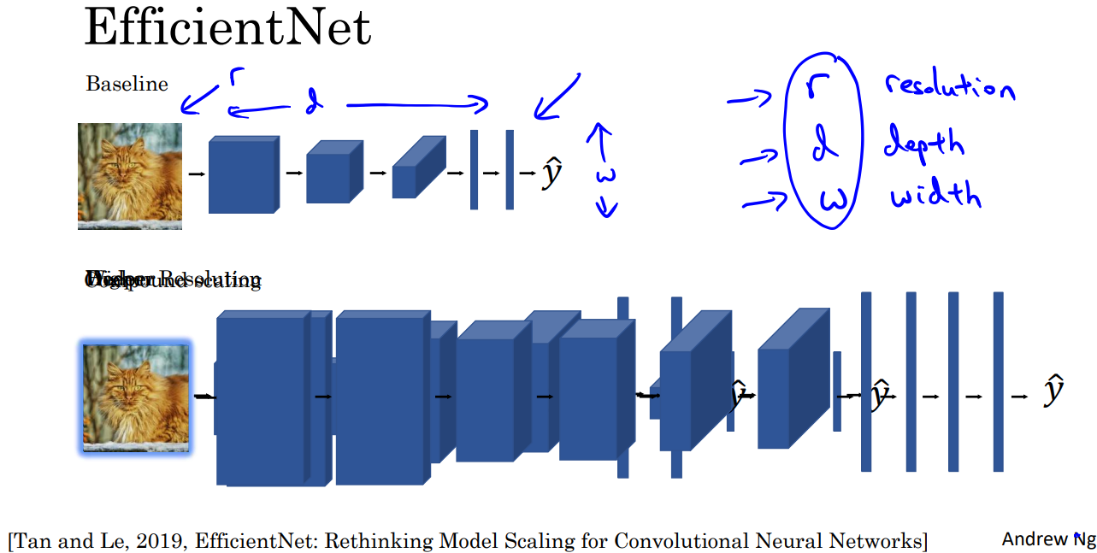

**2.9 Common augmentation method**

* Mirroring
* Random Cropping
* Rotation
* Shearing
* Local warping
* Color shifting
* Distortion

**Week 3 Object detection**

3.1-ObjectLocalization

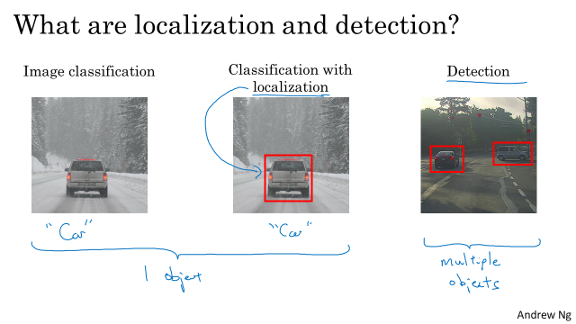

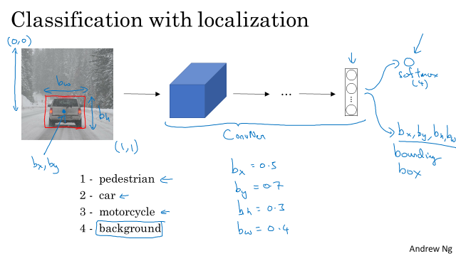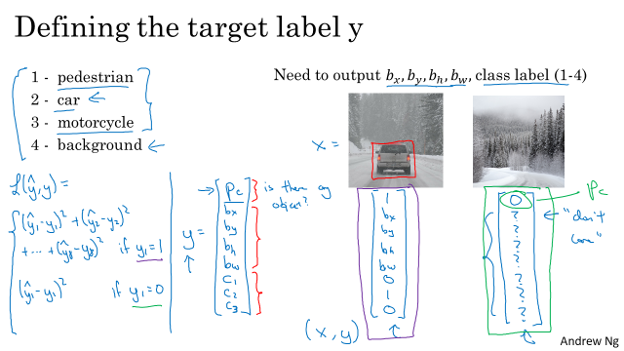

**3.2-LandmarkDetection**

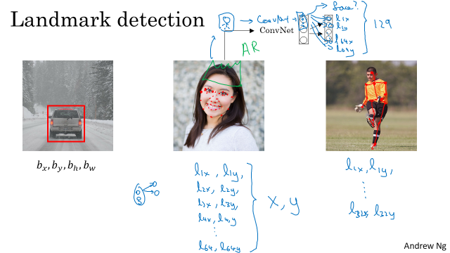

**3.3-ObjectDetection**

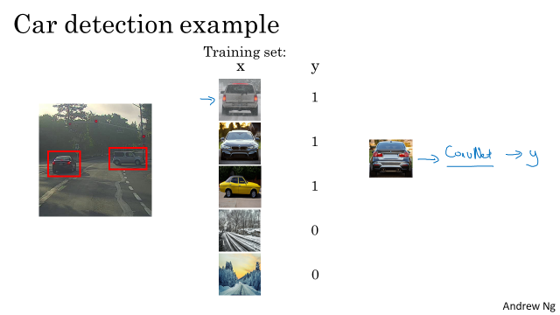

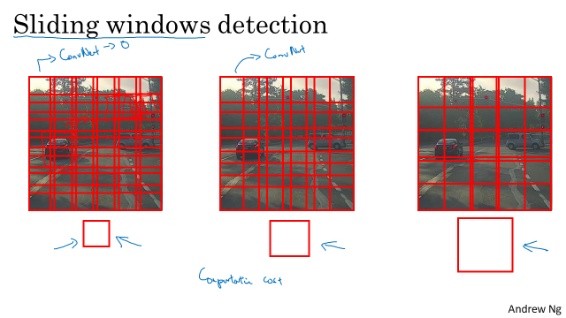

**3.4-ConvImpSlidingWindows**

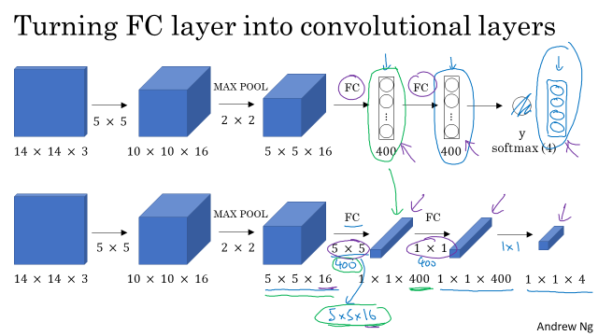

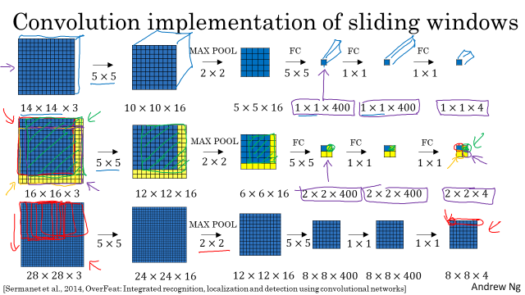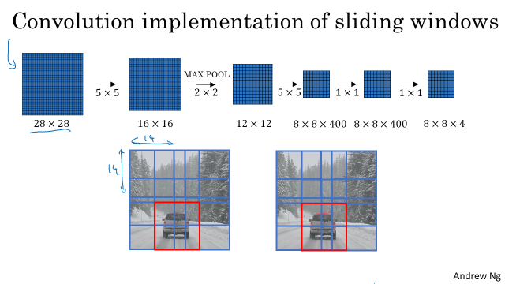

**3.6InstersecOverUnion**

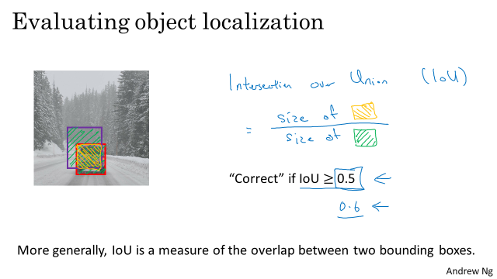

**3.7-NonmaxSuppression**

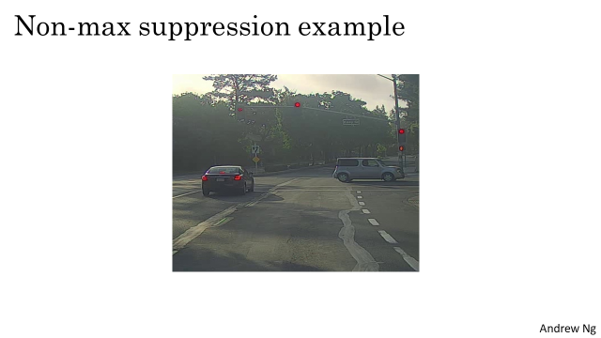

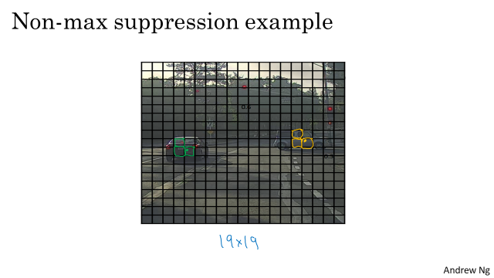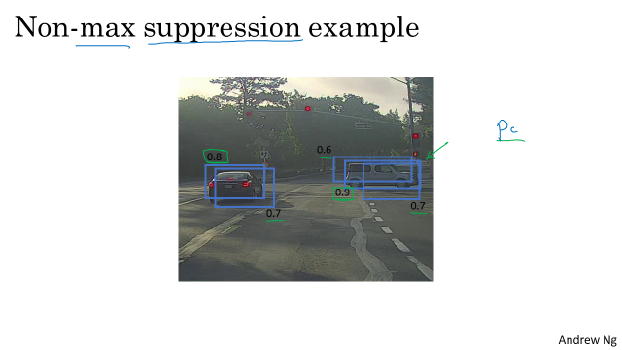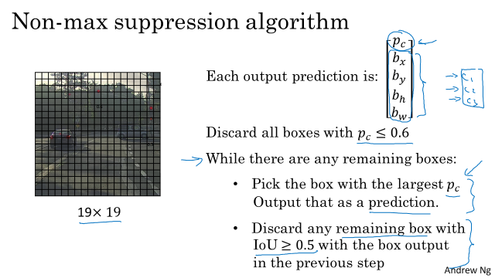

**3.8-AnchorBoxes**

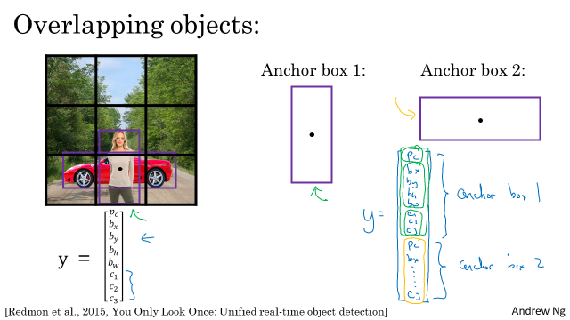

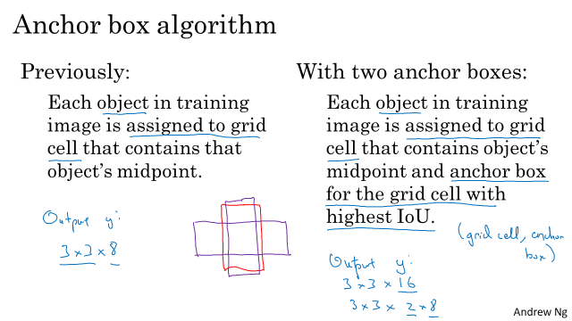

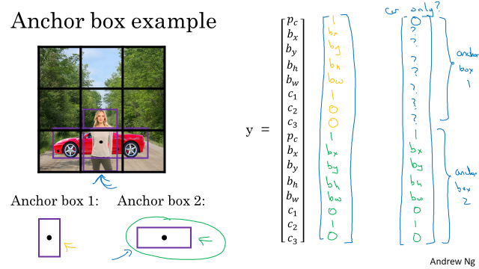

**3.9-YOLOAlgorithm**

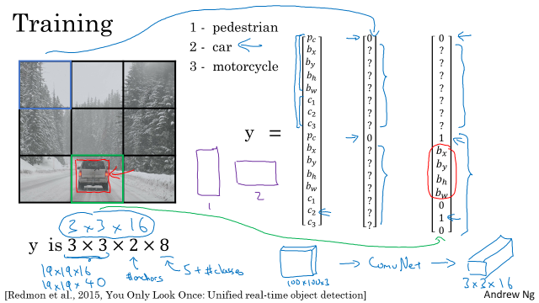

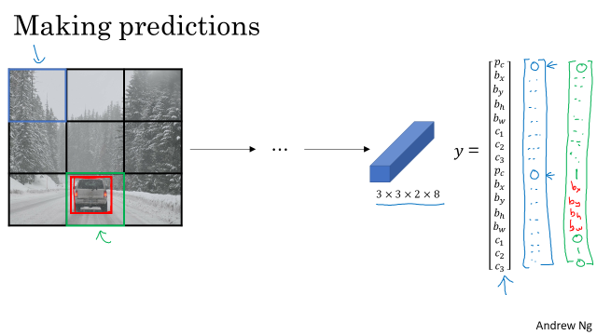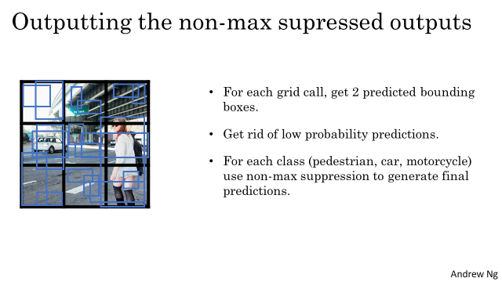

**3.10-RegionProposals**

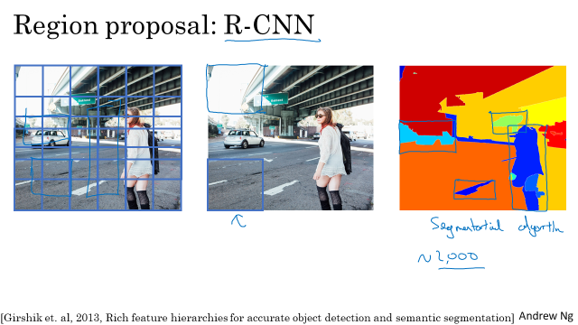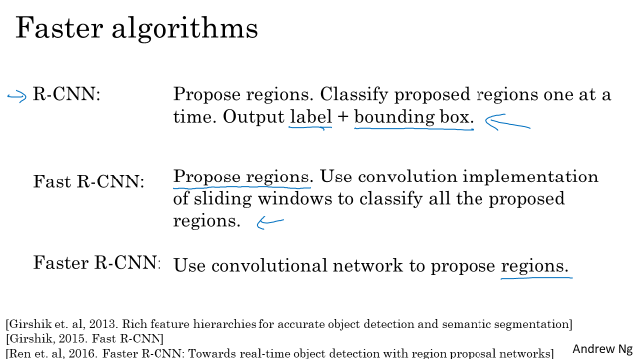

3.11 Semantic segmentation with U-Net

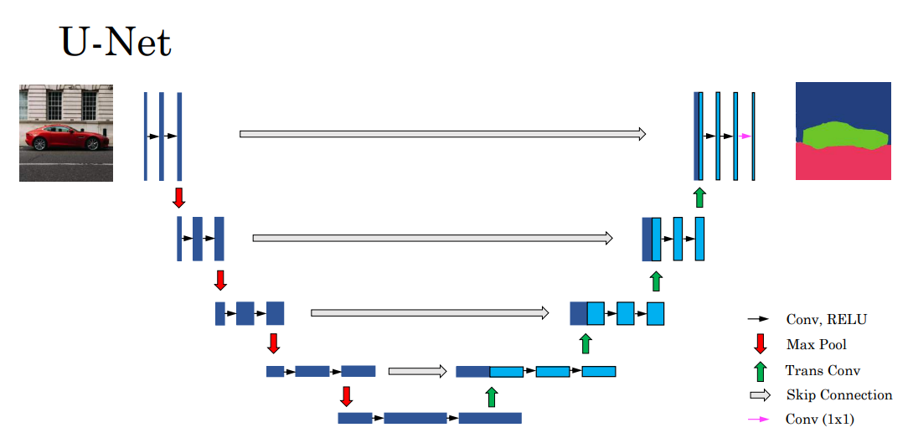

**Week 4 Special applications: Face recognition & Neural style transfer**

**4.1-What Is Face Recognition**

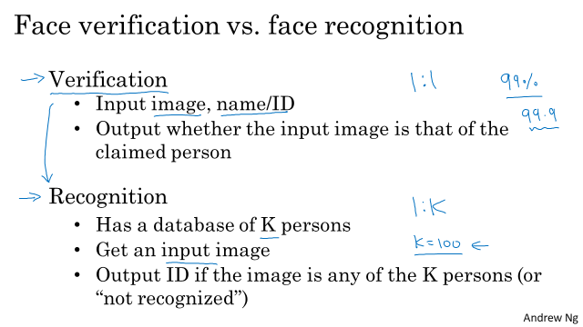

**4.2-One Shot Learning**

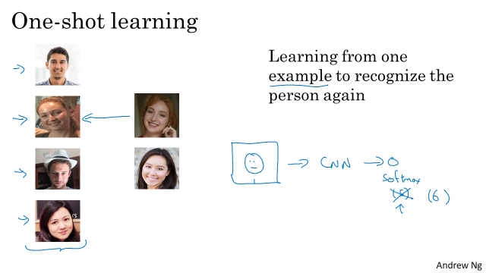

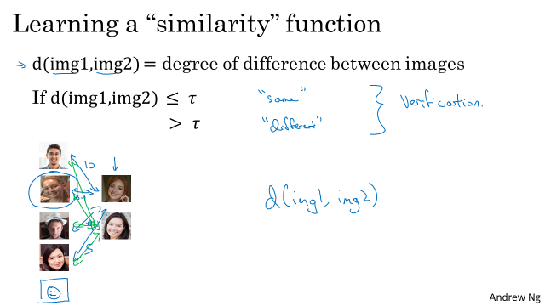

**4.3-Siamese Network**

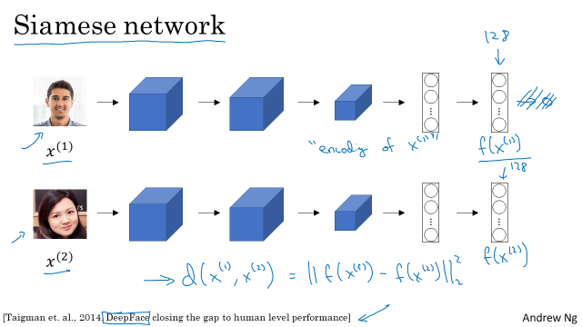

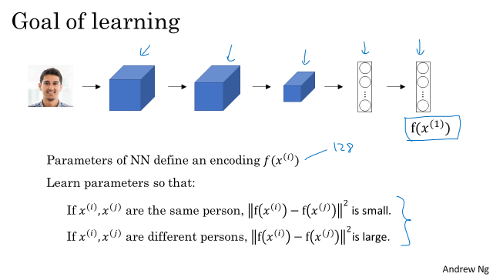

4.4-Triplet Loss

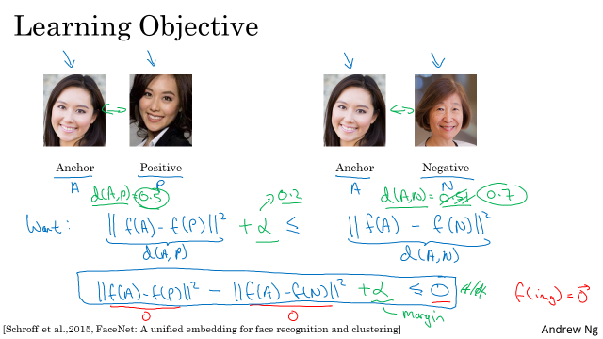

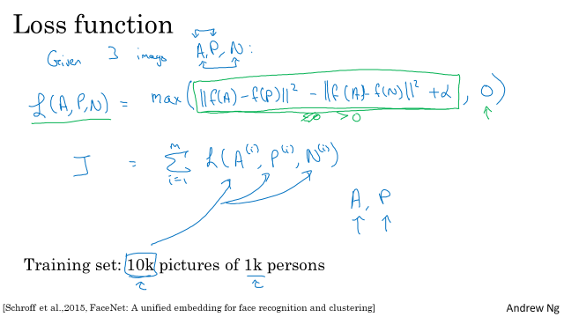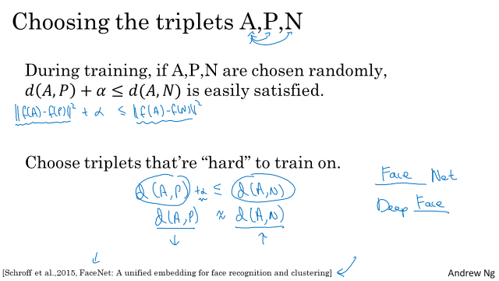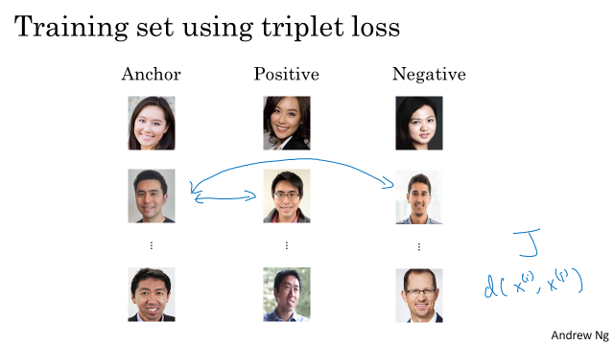

4.5-Face verification and binary classification

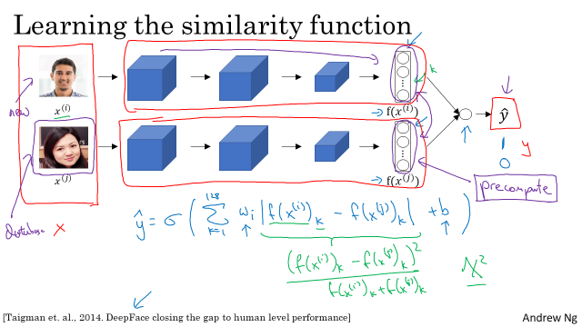

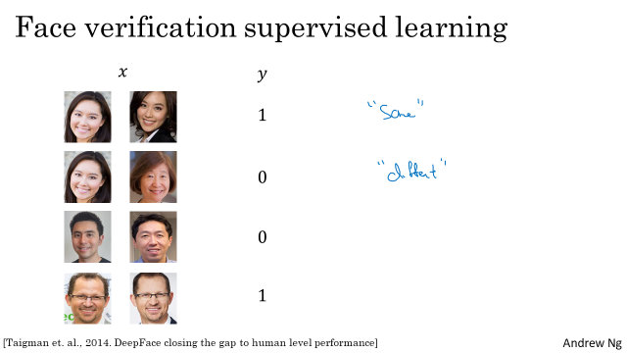

**4.6-What Is Neural Transfer Style**

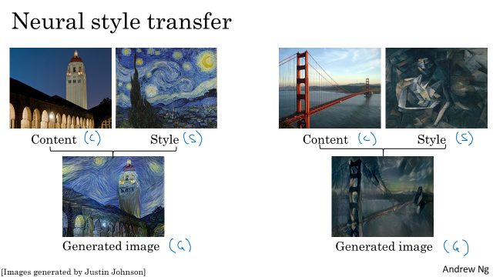

**4.7-What Are Deep CNs Learning**

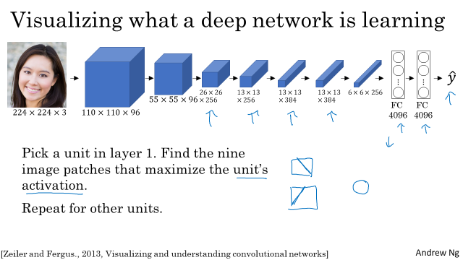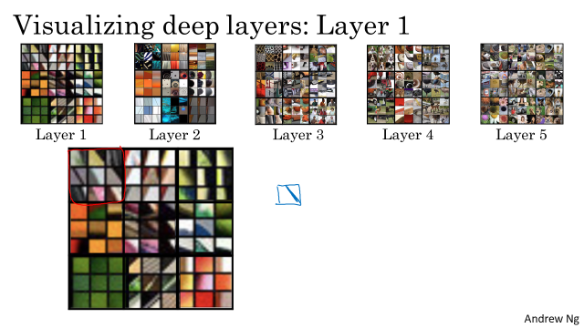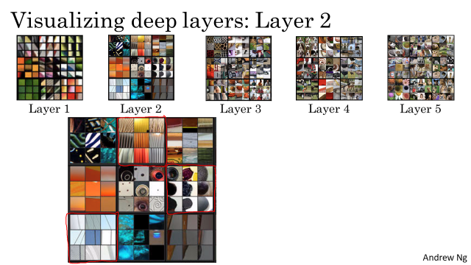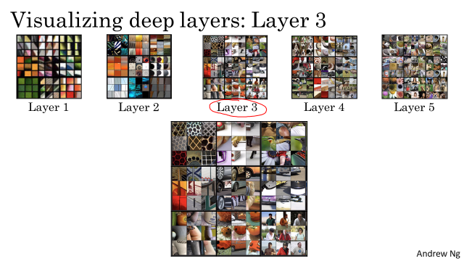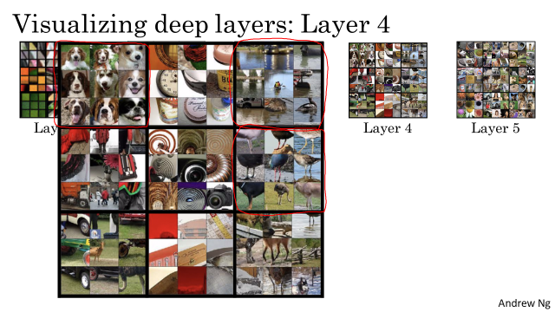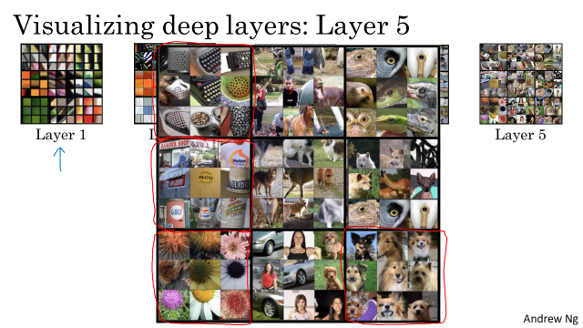

**4.8-Cost Function**

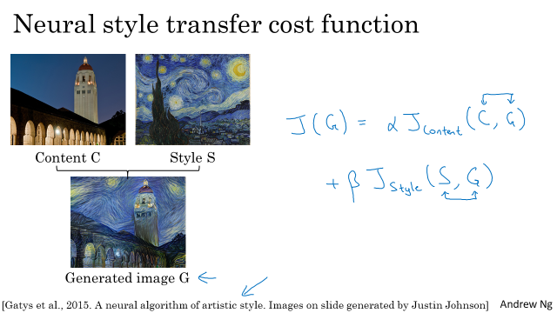

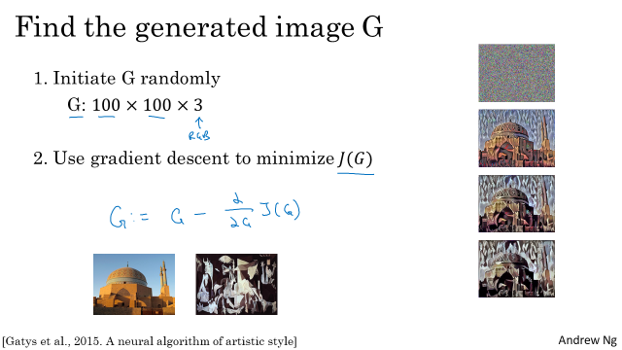

**4.9-Content Cost Function**

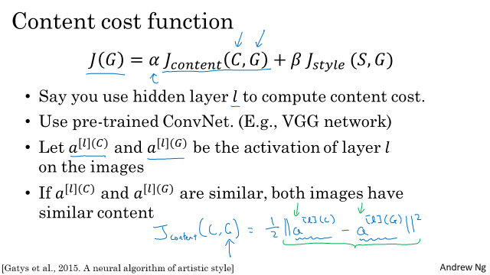

**4.10-Style Cost Function**

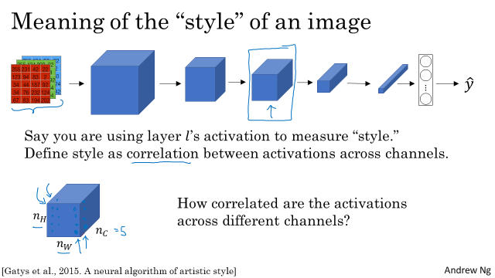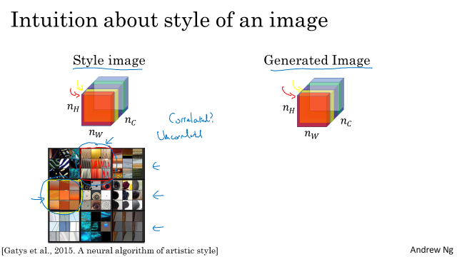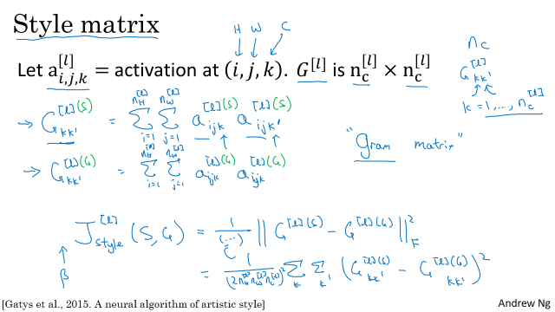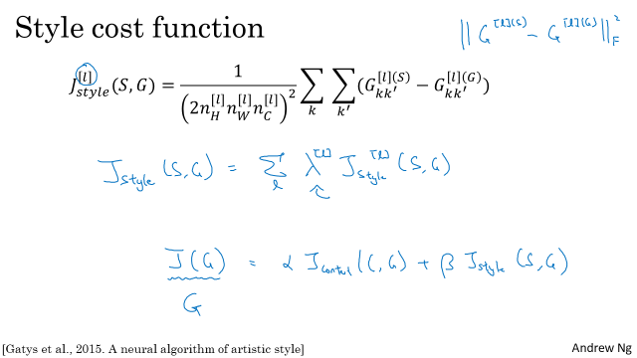

**4.11 1D and 3D generalizations of models**

